STUDY COSTA RICA
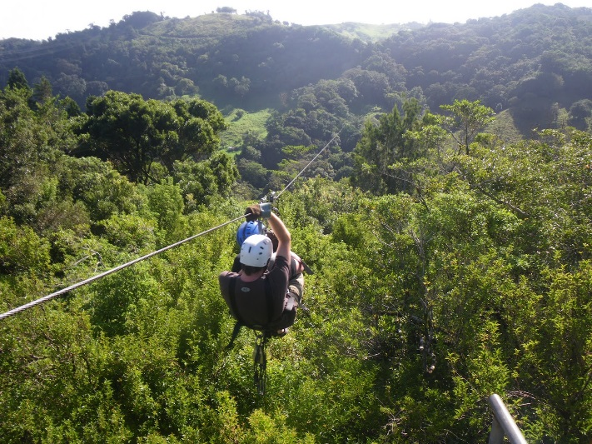
SPRING BREAK 2017

3 hours credit for either
BUSA 2106 – Environment of Business or
BUSA 4800 – Doing Business in Costa Rica
Information Sessions in the Team Room – MEM 131
Wednesday, September 28th 10:00 am and
Thursday, September 29th 3:00 pm
March 10 – 18
$2,200 (approximately, tuition not included) per person covers:
Travel to/from ATL airport --- RT airfare from ATL to San Jose
RT bus fare from San Jose to UGA CR campus --- Room & Meals at the UGA CR campus
Visits to local businesses, including Fair Trade Coffee Plantation and Tilapia Farm
Ride on the World’s Longest Zip Line!
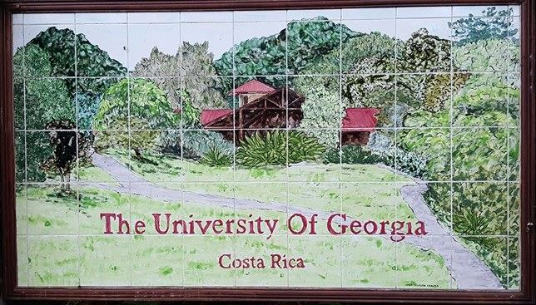

For more information contact: Dale Kelly or Rose Opengart DSC School of Business
dkelly@daltonstate.edu or ropengart@daltonstate.edu
https://dar.uga.edu/costa_rica

